Celebration in Worship
Tenth Sunday after Pentecost
August 18, 2019

We believe the words of Jesus reflect the heart of the Divine:
“I will never turn away anyone who comes to me.”
John 6:37

GATHERING AROUND THE WORD

PRAYER OF PREPARATION
Most Gracious God, we greet you once again in this sacred space. We have come because we need to be reminded of your love and your expectations for our living. We know in our hearts that we need, want and desire your presence in our lives. So we come in prayer and listen for your Word to speak to our hearts and reveal again your desires for us. Amen.

PRELUDE

WELCOME AND ANNOUNCEMENTS (Responsive)
The Lord be with you.
And also with you.

*CALL TO WORSHIP
God of the burning bush, throughout the ages
You have revealed Yourself to the faithful.
Great I AM, help us come to know You more deeply.
God of the fiery furnace, You alone can save us.
Open our eyes to Your presence here,
God of the refiner’s fire, the guiding pillar of flame,
the tongues of Pentecost.
Let Your fire burn among us now, that we might worship You
with all our heart, soul, mind and strength.

*HYMN 192 Lord, the Light of Your Love Is Shining

CALL TO CONFESSION (Leader)
Being human, we never find it easy to ask for forgiveness. But as God's children, called to live in relationship with one another, we know we must speak of how we have hurt others so we might be forgiven and restored to new life. Please join me as we pray to God, singing together…

SUNG PRAYER OF CONFESSION
HYMN 345 In an Age of Twisted Values

A period of silent prayer is observed.

PROCLAIMING THE WORD

ASSURANCE
My friends, be assured that God hears our petitions! God continues to expect of us a life in which justice prevails. This is God’s desire for us. We, God’s forgiven people, are free to live into that desire, for we know God loves us still.
Amen.

*PASSING THE PEACE
The Peace of Christ be with you
And also with you.

CHILDREN’S MESSAGE
SPECIAL MUSIC O Rest in the Lord Sarah Brauer
SCRIPTURE LESSON Luke 12:49-56
SERMON Fire
RESPONDING TO THE WORD

*HYMN 773 Heaven Shall Not Wait

STEWARDSHIP OF CREATION

AN INVITATION TO OFFERING (Leader)
People of God, we have come to that part of our worship when we are invited to respond with thanksgiving to God’s provisions for us. We have an opportunity to participate with God in the care of God’s people. Let our love of God lead us to generosity for the sake of those who need our help.

OFFERTORY
Please use the yellow prayer request cards found in the pew and place them in the offering plate to be included in the prayers of the people and/or the email prayer ministry of CPC.
*DOXOLOGY (Unison)
Praise God, from whom all blessings flow;
Praise God, all creatures here below:
Alleluia! Alleluia!
Praise God, the source of all our gifts!
Praise Christ, whose mighty power uplifts!
Praise the Spirit, Holy Spirit!
Alleluia! Alleluia! Alleluia!

PRAYER OF DEDICATION, PRAYERS OF THE PEOPLE
& THE LORD’S PRAYER
As you share your blessings with us, Gracious God, you show great faith that we will use them wisely and offer them generously to others. So, by faith, may our gifts bring healing to the broken, hope to the despairing, and laughter to those who mourn. Hear us now as we lift before you the joys and concerns of this congregation . . .

Our Father who art in heaven, hallowed be thy name.
Thy kingdom come, thy will be done,
on earth as it is in heaven.
Give us this day our daily bread,
and forgive us our debts, as we forgive our debtors,
And lead us not into temptation, but deliver us from evil.
For thine is the kingdom and the power
and the glory, forever. Amen.

*HYMN 546 Lord, Dismiss Us with Your Blessing

*CHARGE & BENEDICTION

POSTLUDE

* Indicates a time in the service when you are invited to rise in body or spirit.

Visitors, friends, members, welcome to worship! Please feel free to participate in ways that you feel led, and comfortable if you would just like to observe. If you are interested in learning more about making Central Presbyterian your church home, please speak with Pastor Jennifer or the welcome greeter following the service.

Visitors, friends, members, welcome to worship!
We are glad you are here and invite you to
join us for coffee after the worship service.
THIS WEEK AT CENTRAL
10:00am Worship, Sanctuary
11:00am Fellowship, Fellowship Hall
OFFICE HOURS
Monday – Thursday, 8:30am-12:30pm, 1:30pm-4:00
Friday - Closed

Mon, Aug 19 11:00am Bible Study Parlor
4:30pm Finance Committee Pastor’s Office
5:30pm Session 121-A
6:30pm Badminton Group Fellowship Hall
Tues, Aug 20 1:30pm Church Properties Pastor’s Office
3:00pm Personnel Committee Pastor’s Office
Thurs, Aug 22 1:30pm Interfaith Family Shelter Parlor

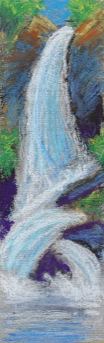
SACRED ARTS WEEK OCTOBER 20-26 - Pastor Jennifer is taking a group to the Grunewald Guild for a week of art, faith, and community October 20 - 26. It is a bit like church camp for grown-ups! The Guild is a special place in the little community of Plain, WA, between Leavenworth and Lake Wenatchee.
Each day is framed by morning and evening prayer together. Every person signs up for a class in a specific art form and will have time with and without instruction in the studio. Prices vary depending on what class you take and what kind of accommodation you choose. To get more details or to sign up for the week, you can go to the Grunewald Guild web site here: https://grunewaldguild.com/sacred-arts-week-fall-2019/


FLOWERS TODAY – Have been given to the Glory of God by Frank & Nancy Carlton in honor of Frank’s 86th birthday on August 28th.

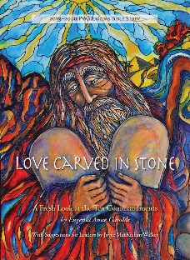
PW CIRCLES RESUME MEETING IN SEPTEMBER – Love Carved in Stone, A Fresh Look at the Ten Commandments, by Eugenia Anne Gamble is the 2019-2020 Bible study. Books are now available in the church office for $11.

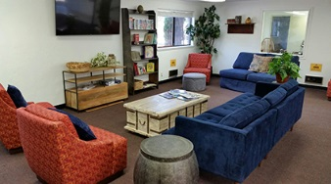
INTERFAITH FAMILY SHELTER MEALS -MCD will be having a planning meeting for the Interfaith Family Shelter at the Annex on Thursday, August 22 at 1:30pm at Central in the Parlor. Our dates to serve at the Family Shelter are September 30- October 6.

During this meeting we hope to determine the morning breakfast team and schedule 7 dinner cooking teams for the week (one group for each night of the week). We will be asking the congregation to provide salads and desserts and help with clean-up for the dinner meals.

Contact Pam Sheridan with questions or to sign up for volunteering at 541-914-0786 or jjs3316@comcast.net.
STRICTLY ORGANIC COFFEE - for $14 a pound, is available in the Narthex from Carolyn Keener after worship today. Buy a bag of decaf or regular coffee; it's certified organic, shade grown, and farmer friendly. Any profit Central makes will be given to Presbyterian Disaster Assistance.
FISH - Fruit is one item that FISH does not purchase but is happy to distribute when it can. Canned applesauce and peaches, dried raisins and apricots. Give what you enjoy eating. Place your donations in the wicker basket on Sunday, and they will be provided to those who seek help from FISH.
COIN OFFERINGS FOR AUGUST - are designated for SquareOne Villages. SquareOne Villages is a non-profit organization dedicated to creating self-managed communities of cost-effective tiny homes for people in need of housing. These include Opportunity Village and Emerald Village in Eugene and Cottage Village in Cottage Grove. Members of Central have been actively involved and served on the Board of SquareOne Villages. The National Presbyterian Women gave a $100,000 grant to Cottage Village, and construction has begun on the first home. SquareOne seeks to bridge the gap between living on the streets and conventional housing with a variety of simple cost effective housing options. Thank you for supporting them with your coins on Sunday morning.

We thank the following faithful people who
Lectionary –
Sunday, August 25
Jeremiah 1:4-10
Ps. 71:1-6
Hebrews 12:18-29
Luke 13:10-17

are helping behind the scenes today:

Ministers All
Coffee Hour Fellowship Committee
Deacon on Call Louise DeKluyver
Worship Leader Jane Holmes
Welcome Greeter Louise DeKluyver
Transport Team Margaret Knudson
Pastor Rev. Jennifer Martin
Organist Dan Rinnan
Building Host Joe Olney
Sound Technician Steve Stermer

A CARING, INQUIRING, INCLUSIVE
COMMUNITY OF FAITH
August 18, 2019
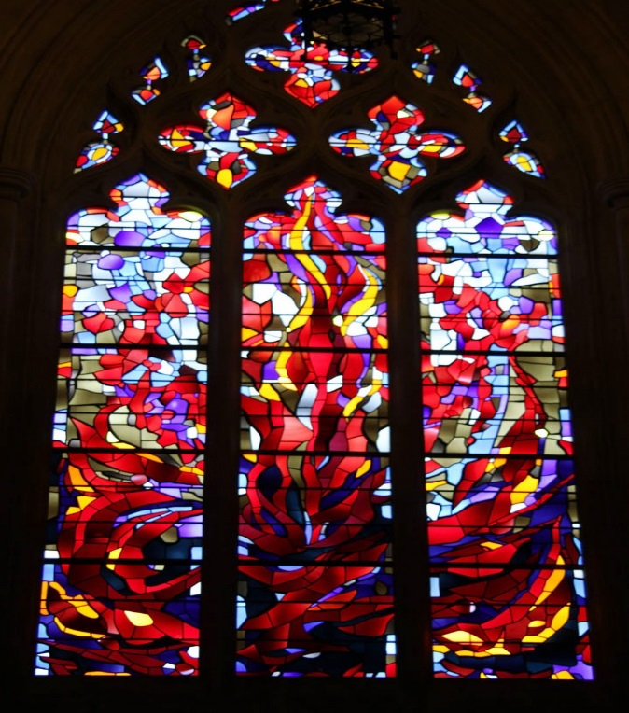

Fire, stained glass by Robert Pinart and Dieter Goldruhle,
Washington National Cathedral, 1979.

555 East 15th Avenue, Eugene, OR 97401
email:centralpresbyterianeugene@gmail.com
www.centraleugene.church
541- 345-8724
Find us on Facebook at Central Presbyterian Church Eugene, OR

